Some Verbs
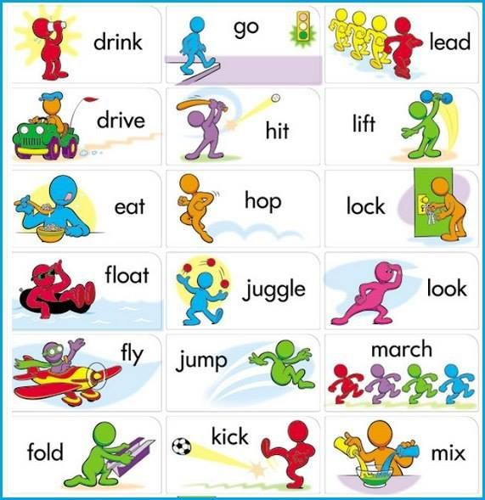
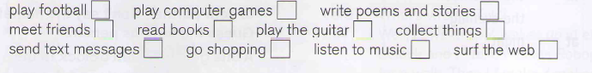

The Present Simple
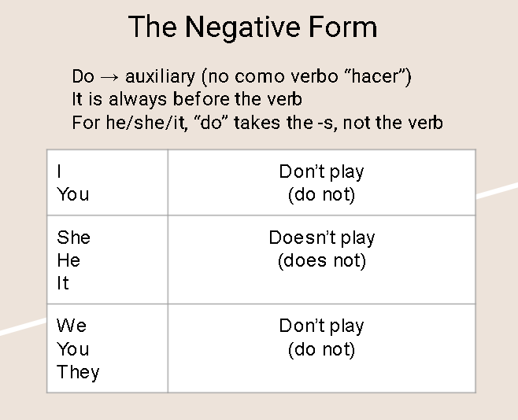
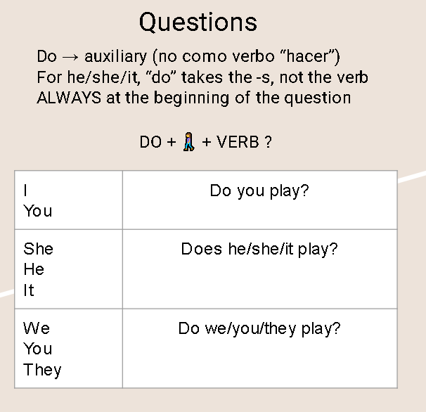

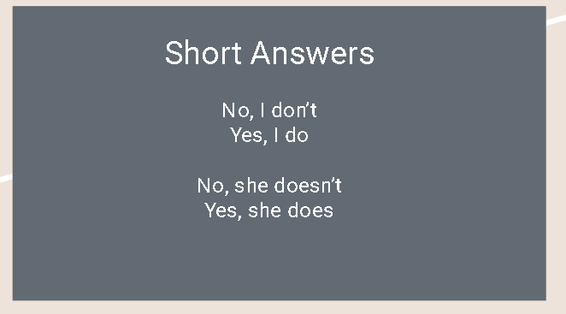
Activities
https://es.liveworksheets.com/worksheets/en/English_as_a_Second_Language_(ESL)/Present_Simple/Present_simple_affirmative_and_negative_za26318ec
https://es.liveworksheets.com/worksheets/en/English_as_a_Second_Language_(ESL)/Present_Simple/Present_Simple_hr39728hk
